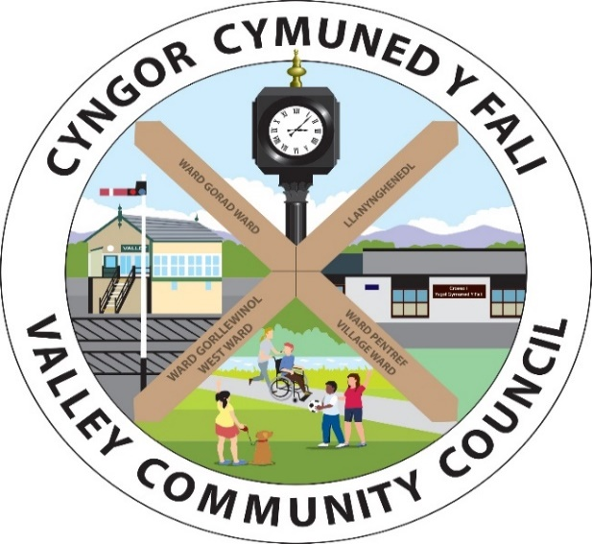

Clerc / Clerk: Rhianwen Sheldon
Cyfeiriad/Address: 27 Alltwen, Llysfaen, Colwyn Bay LL29 8PG
Ffon/Tel: 07786253828
Ebost/Email: valleycommunitycouncil@gmail.com
Gwefan: www.cyngor-cymuned-fali.cymru
Website: www.valley-community-council.wales
 | Hysbysaf drwy hyn y bydd cyfarfod nesaf Cyngor Cymuned y Fali yn cael ei gynnal yn Ysgol Gymunedol y Fali ar  Nos Fercher, 17 Medi 2025 am 7pm.  Mae aelodau'r Cyngor drwy hyn yn cael eu galw i fynychu at ddibenion trafod y busnes canlynol. Mae croeso i drigolion y Gymuned fynychu. Mae dolen Zoom i'r cyfarfod isod. Dylai unrhyw un sy'n mynychu fod yn ymwybodol y gall y cyfarfod gael ei recordio. |  |  |  | I hereby give notice that the next Valley Community Council meeting will be held at the Valley Community School on  Wednesday, 17 September 2025 at 7pm.  Members of the Council are hereby summoned to attend for the purpose of transacting the following business. Residents of the Community are welcome to attend. A Zoom link to the meeting is given below. Anyone attending should be aware that the meeting may be recorded.
Linc Zoom i ymuno a’r cyfarfod / Link to Join Zoom Meeting
https://us06web.zoom.us/j/82565222348?pwd=b3r7rGbtSn9uZeq67xRn56RKa3jXj8.1

Rhianwen Sheldon
Clerc Cyngor Cymuned Y Fali / Clerk to the Valley Community Council
 |  | RHAGLEN |  |  | AGENDA
125/2526 |  | Croeso a Sylwadau Agoriadol |  |  | Welcome and Opening Remarks
126/2526 |  | Derbyn ymddiheuriadau |  |  | To accept apologies
127/2526 |  | Derbyn Datgan Buddiant Personol a  Rhagfarnol |  |  | To receive Declaration of interest Personal and Prejudicial Interest
128/2526 |  | Dylan Herbert / Eve Ashby  Cyflwyniad National Grid |  |  | Dylan Herbert /Eve Ashby  National Grid Presentation
129/2526 |  | Caniatau i’r cyhoedd siared ar unrhyw eitem ar yr agenda neu ofyn cwestiynau (3 munud). |  |  | To allow the public to speak on any item on the agenda or ask questions (3 mins).
130/2526 |  | Cyfethol i Sedd Wag – Ward Llanynghenedl |  |  | Co-option Vacant Seat – Llangynghendl Ward
131/2526 |  | Cadarnhau cofnodion cyfarfod 20/08/25 |  |  | To confirm minutes of meeting 20/08/25
132/2526 |  | Trafod materion yn codi o’r cofnodion |  |  | To discuss matters arising from the minutes
133/2526 |  | Cadarnhau Penoida Clerk/SAC |  |  | To confirm appointment of Clerk /RFO
134/2526 |  | Derbyn Setliad Cyflog clercod ar gyfer 2025/2631,187.28 |  |  | To accept Clerks Pay Settlement for 2025/26
135/2526 |  | Derbyn Balans Cyfrifon hyd at 31.08.2025 |  |  | To Accept Balance of Accounts at 31.08.2025
 |  | Cyfri Elusennol - Busnes |  | £31,187.28 | Business - Charitable Account |  |  | £31,187.28
 |  | Cronfa wrth gefn - Busnes |  | £22,093.31 | Business - Reserves |  |  | £22,093.31
 |  | Cyfri Elusennol - Ynys Wen |  | £7022.59 | Ynys Wen - Charitable Account |  |  | £7022.59
 |  | Cromfa wrth gefn – Ynys Wen |  | £20,627.56 | Ynys Wen Reserves |  |  | £20,627.56
 |  | Cyfanswm |  | £80,930.74 | Total |  |  | £80,930.74
 |  | Arian Busnes ar gael 01.09.25 - £31,187.28 |  |  | Business funds available 01.09.25 - £31,187.28
136/2526 |  | Cymeradwyo Taliadau fel a ganlyn: |  |  | To Approve payments as follows:
 |  | Johnstones Dec Centre – Paent ffens - £72.00 |  |  | Johnstones Dec Centre – Fence paint - £72.00
 |  | Humphreys Waste Recycling anf 32307 - £36.00 |  |  | Humphreys Waste Recycling Inv 32307 - £36.00
 |  | Liam Jones AGS Torri coed anf 1566 - £576.00 |  |  | Liam Jones AGS Tree cutting inv 1566 - £576.00
 |  | Liam Jones AGS Torri Glaswellt anf 1567 - £1,483.20 |  |  | Liam Jones AGS Grass Cutting Inv 1567 - £1,483.20
 |  | Sound Induction Sys Ltd Offer cyfieithu - £1,765.80 |  |  | Sound Induction Sys Ltd Translation Equip - £1,765.80
 |  | R Sheldon Cyflog Clerc Medi ac ol-daliad - £984.61 |  |  | R Sheldon Clerk Salary Sept & back pay - £984.61
 |  | R Sheldon Costau Gweinyddol Medi - £21.00 |  |  | R Sheldon Admin costs September - £21.00
 |  | Ag unrhyw fil arall dyledus ar 17.09.25 |  |  | Plus any bill that falls due by 17.09.25
 |  | Taliadau Uniongyrchol / Direct Debits
 |  | Cwmni / Company | Mis/Month | Cyflenwad/Supply | Parc Mwd | Cloc / Clock | Ynys Wen | Car Park / Maes Parcio
 |  | Scottish Power | Medi / Sept | Trydan / Electric | £38.00
 |  | British Gas | Medi / Sept | Trydan / Electric |  | £14.95
 |  | CSYM / IOACC | Medi / Sept | Treth Cyngor / Council Tax | £48.00 |  |  | £202.00
137/2526 |  | Materion Plwyfol |  |  | Parochial Matters
 |  | Trafod Materion Parc Mwd  - Fandaliaeth  - Grant £10k i'r Ardal Chwarae  - Biniau sbwriel ar goll |  |  | Parc Mwd  - Vandalism  - Play Area £10k grant  - Missing refuse bins
 |  | Cymeradwyo pryfles Grŵp Cymunedol y Fali |  |  | To approve Valley Community Group Lease
 |  | Cymeradwyo Polisi Gosod |  |  | To Approve Lettings Policy
 |  | Trafod Buses Gorad |  |  | To discuss Gorad Buses
 |  | Derbyn diweddariad am Fynwent Ynys Wen |  |  | Accept update regarding Ynys Wen cemetery
 |  | Derbyn diweddariad gan y Cyfreithiwr par llwybr |  |  | Accept update from the Solicitor re pathway
 |  | Gwaith Ffordd arfaethedig ar y Grid Cenedlaethol ar Lon Gorad, Y Fali |  |  | Proposed National Grid Roadworks on Gorad Road, Valley
139/2526 |  | Asesiad Panel Perfformiad |  |  | Panel Performance Assessment
140/2526 |  | Trefniadau sul y Cofio |  |  | Remembrance Sunday atrrangements
141/2526 |  | Ymgynghori ar geisiadau a penderfyniadau Cynllunio |  |  | To Consult on Planning Applications & Decisions
 |  | Ymgynghoriad Ceisiadau Cynllunio  - HHP/2025/142: Cais llawn am newidiadau ac estyniad yn Beudy Bach, Penybont, Y Fali |  |  | Planning Applications for Consultation  - HHP/2025/142: Full application for alterations and extension at Beudy Bach, Penybont , Valley
 |  | Penderfyniadau Cynllunio:  - FPL/2025/172: Gorsaf Wasanaeth Dyffryn Caniatáu |  |  | Planning Decisions:  - FPL/2025/172: Dyffryn Service Station Granted
142/2526 |  | Gohebiaeth (wedi cylchredeg)  - £5k Grantiau Balchder Bro i gefnogi Cymunedau Ynys Môn  - Cylchlythyr Awel y Môr  - Cau Ffordd dros dro – Croesfan Reilffordd y Fali 4 wythnos o 27/9/25 |  |  | Correspondence (Circulated):  - £5k Balchder Bro Grants to support Anglesey Communities  - Awel y Môr Newsletter  - Temp Road Closure – Valley Level Crossing 4 weeks from 27/9/25
143/2526 |  | Ymgynghoriad (wedi cylchredeg)  - Dim |  |  | Consultation (Circulated):  - None
144/2526 |  | Derbyn adborth gan:  - Fforwm Gyswllt Cynghorau Tref a Chymuned – cyfarfod nesaf 20/10/25  - ULLC:Pwyllgor Ardal Ynys Môn  - Bwrdd Llywodraethwyr yr Ysgol  - Cynghrair Bro Llynnoedd |  |  | To receive feedback from:  - Town and Community Council Liaison Forum - next meeting 20/10/25  - OVW: Ynys Mon Area Meeting  - School Governing Board  - Bro’r Llynnoedd Alliance
145/2526 |  | Adolygu Anghenion Hyfforddiant |  |  | Review Training Needs
146/2526 |  | Eitemau i raglen y cyfarfod nesaf |  |  | Items for the agenda of the next meeting
147/2526 |  | Dyddiad Cyfarfod Nesaf: Ysgol Gymuned y Fali ac ar Zoom 15/10/25 am 7.00 yh |  |  | Date of Next Meeting: Valley Community School and on Zoom. 15/10/25 at 7.00 pm.

