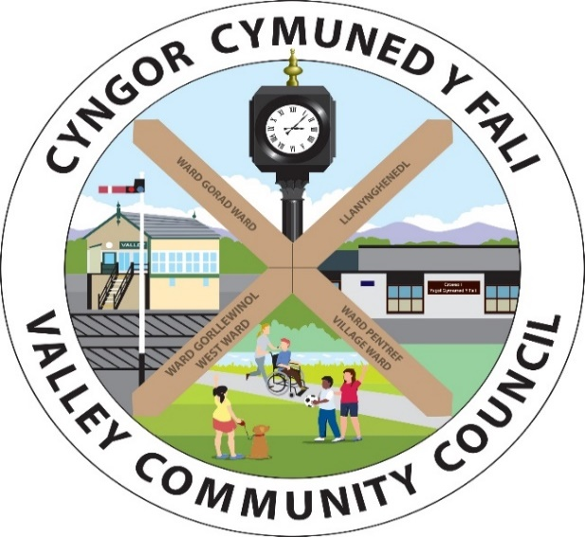
Clerc/Clerk: Rhianwen Sheldon
Cyfeiriad/
Address: 27 Alltwen, Llysfaen, Colwyn Bay, LL29 8PG
Ffon/Tel: 07786253828
Ebost/Email: valleycommunitycouncil@gmail.com
Safle We: http://www.cyngor-cymuned-fali.cymru
Website: http://www.valley-community-council.wales

Agenda Cyfarfod Pwyllgor Parciau / Agenda of Parks Committee Meeting
24/09/2025 - 7.00 pm
Lleoliad/Location: Parc Mwd, Valley

 | Croeso | Welcome
 | Presennol/Ymddiheuriadau | Present/Apologies
 | Confnodion y cyaforfod diwethaf a  meterion yn codi | Minutes of the last meeting & matters arising
 | Cyllid | Finance
 | Adborth gan Grŵp Cymunedol y Fali | Feedback from Valley Community Group
 | Adborth gan Glwb Pêl-droed Iau y Fali | Feedback from Valley Junior Football Club
 | Diweddariadau  - Ystafell Gyfarfod a Chegin  - Dyddiadur Google  - Cynwysyddion  - Oergell | Updates  - Meeting Room & Kitchen  - Google Diary  - Containers  - Fridge
 | Biniau ym Mharc Mwd | Bins at Parc Mwd
 | Adroddiadau arolygu ROSPA & CSYM | ROSPA & CSYM Inspection Reports
 | Adroddiad Atal Troseddu | Crime Prevention Report
 | Cynllun Gweithredu Trwsio a Gwellianau | Action Plan for Repairs & Improvements
 | Unrhyw fater arall | Any other business

