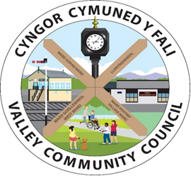

Clerc / Clerk: Rhianwen Sheldon

Cyfeiriad/Address: 27 Alltwen Llysfaen Colwyn Bay LL29 8PG

Ffon/Tel: 07786253828

Ebost/Email: [valleycommunitycouncil@gmail.com](mailto:valleycommunitycouncil@gmail.com)

Safle We: [www.cyngor-cymuned-fali.cymru](http://www.cyngor-cymuned-fali.cymru)

Website: www.valley-community-council.wales

**Agenda Cyfarfod Pwyllgor Cyllid a Phersonnèl / *Agenda Finance & Personnel Committee***

**23/9/25 - 7.30 yh/pm**

***Cyfarfod Rhithiol ar Zoom. /Remote Meeting on Zoom***

**Linc Zoom i ymuno â’r cyfarfod / Link to join Zoon meeting:**

<https://us06web.zoom.us/j/85104264064?pwd=r2BAUT3hT5ooyMDd3kaVbzdjljMREM.1>

|  |  |  |
| --- | --- | --- |
|  | Croeso s Sylwadau Agoriadol | Welcome and Opening Remarks |
|  | Current Finance Position | Current Finance Position |
|  | Cyllideb ddrafft gychwynnol 2026/27 | Initial draft budget 2026/27 |
|  | Maes Parcio Cyhoeddus | Public Car Park |
|  | Unrhyw fater arall | Any other matters |