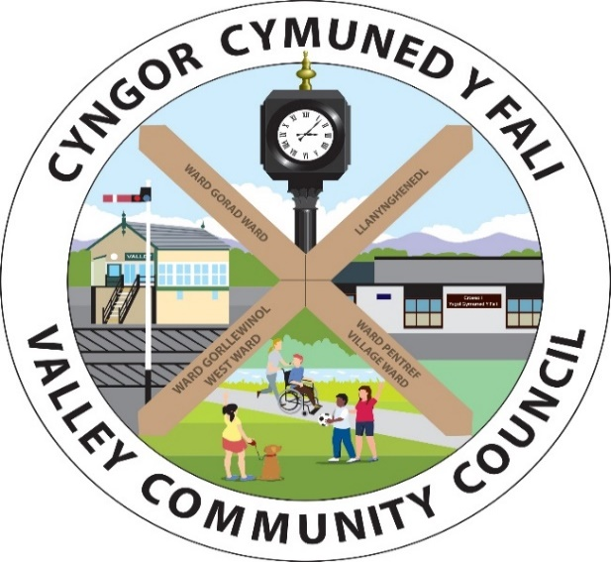
She

Clerc / Clerk: Rhianwen Sheldon
Cyfeiriad/Address: 27 Alltwen, Llysfaen, Colwyn Bay LL29 8PG
Ffon/Tel: 07786253828
Ebost/Email: valleycommunitycouncil@gmail.com
Gwefan: www.cyngor-cymuned-fali.cymru
Website: www.valley-community-council.wales
 | Rwy'n rhoi rhybudd drwy hyn y bydd cyfarfod (arbenning) nesaf Cyngor Cymuned Y Fali yn cael ei gynnal drwy Zoom ar  Nos Fawrth, 5 Awst 2025 am 7.30pm.  Mae aelodau'r Cyngor drwy hyn yn cael eu galw i fynychu at ddibenion trafod y busnes canlynol. Mae croeso i drigolion y Gymuned fynychu. Mae'r ddolen Zoom i'r cyfarfod isod. Dylai unrhyw un sy'n mynychu fod yn ymwybodol y gallai'r cyfarfod gael ei recordio. |  |  |  | I hereby give notice that the next Valley Community Council (extra ordinary) meeting will be held via Zoom on  Tuesday, 5 August 2025 at 7.30pm.  Members of the Council are hereby summoned to attend for the purpose of transacting the following business. Residents of the Community are welcome to attend. The Zoom link to the meeting is given below. Anyone attending should be aware that the meeting may be recorded.
Linc Zoom i ymuno a’r cyfarfod / Link to Join Zoom Meeting
https://us06web.zoom.us/j/85313526917?pwd=fjnwZNWqHpU4OKTLt6JmJYX5jMHBvL.1

Rhianwen Sheldon
Clerc Cyngor Cymuned Y Fali / Clerk to the Valley Community Council
 |  | RHAGLEN |  |  | AGENDA
100/2526 |  | Croeso a Sylwadau Agoriadol |  |  | Welcome and Opening Remarks
101/2526 |  | Derbyn ymddiheuriadau |  |  | To accept apologies
102/2526 |  | Derbyn Datgan Buddiant Personol a  Rhagfarnol |  |  | To receive Declaration of interest Personal and Prejudicial Interest
103/2526 |  | Caniatau i’r cyhoedd siared ar unrhyw eitem ar yr agenda neu ofyn cwestiynau (3 munud). |  |  | To allow the public to speak on any item on the agenda or ask questions (3 mins).
104/2526 |  | Cadarnhau cofnodion cyfarfod 18.06.2025 |  |  | To confirm minutes of meeting 16.07.25
105/2526 |  | Trafod materion yn codi o’r cofnodion |  |  | To discuss matters arising from the minutes
106/2526 |  | Ynys Wen  - Cymeradwyo'r Achos Busnes ar gyfer Benthyciad PWLB a’I argymhellion |  |  | Ynys Wen  - To approve the Business Case for PWLB Loan and its recommendations
107/2526 |  | Cymeradwyo cyllid ar gyfer trosglwyddo swydd clerc |  |  | To approve funding for clerk’s post handover
108/2526 |  | Cynhwysydd Grŵp Cymunedol y Fali |  |  | Valley Community Group Container
109/2526 |  | Derbyn Balans Cyfrifon hyd at 31.07.25 |  |  | To Accept Balance of Accounts at 31.07.25
 |  | Cyfri Elusennol - Busnes |  | £12,599.24 | Business - Charitable Account |  |  | £12,599.24
 |  | Cronfa wrth gefn - Busnes |  | £22,093.31 | Business - Reserves |  |  | £22,093.31
 |  | Cyfri Elusennol - Ynys Wen |  | £6,817.59 | Ynys Wen - Charitable Account |  |  | £6,817.59
 |  | Cromfa wrth gefn – Ynys Wen |  | £20,627.56 | Ynys Wen Reserves |  |  | £20,627.56
 |  | Cyfanswm |  | £62,137.70 | Total |  |  | £62,137.70
 |  | Arian Busnes ar gael 01.08.25 - £12,599.24 |  |  | Business funds available 01.08.25 - £12,599.24
110/2526 |  | Cymeradwyo Taliadau fel a ganlyn: |  |  | To Approve payments as follows:
 |  | Amazon colfachau drws garej - £75.35 |  |  | Amazon hinges garage door - £75.35
 |  | Liam Jones Torri Glaswellt Anf 1551 - £1557.60 |  |  | Liam Jones Grass Cutting Inv 1551 - £1557.60
 |  | Denbigh Plant Services - Brushcutter - £445.20 |  |  | Denbigh Plant Services - Brushcutter - £445.20
 |  | Stermat lladdwr chwyn - £55.07 |  |  | Stermat weedkiller - £55.07
 |  | Shell Expressway Petrol Strimmer - £8.06 |  |  | Shell Expressway Petrol Strimmer - £8.06
 |  | Môn Fire Management Ltd Profi PAT - £19.80 |  |  | Môn Fire Management Ltd PAT Testing - £19.80
 |  | Amazon Gwifren Strimmer - £19.49 |  |  | Amazon Strimmer Wire - £19.49
 |  | Ag unrhyw fil arall dyledus ar 05.08.25 |  |  | Plus any bill that falls due by 05.08.25
 |  | Taliadau Uniongyrchol / Direct Debits
 |  | Cwmni / Company | Mis/Month | Cyflenwad/Supply | Parc Mwd | Cloc / Clock | Salaries / Cyflogau | Car Park / Maes Parcio
 |  | Scottish Power | Awst/August | Trydan / Electric | £38.00
 |  | CSYM / IOACC | Awst/August | Treth Cyngor / Council Tax | £48.00 |  |  | £202.00
 |  | ThEM / HMRC | Ebrill i Gorffennaf / April to July | PAYE & NIC /TAW a YG |  |  | £914.58
111/2526 |  | Ymgynghori ar geisiadau a penderfyniadau Cynllunio |  |  | To Consult on Planning Applications & Decisions
 |  | Ymgynghoriad Ceisiadau Cynllunio  - Dim |  |  | Planning Applications for Consultation  - None
 |  | Penderfyniadau Cynllunio:  - Dim |  |  | Planning Decisions:  - None
112/2526 |  | Eitemau i raglen y cyfarfod nesaf |  |  | Items for the agenda of the next meeting
113/2526 |  | Dyddiad Cyfarfod Nesaf: Ysgol Gymuned y Fali ac ar Zoom 17.09.25 am 7.00 yh |  |  | Date of Next Meeting: Valley Community School and on Zoom. 17.09.25 at 7.00 pm.

